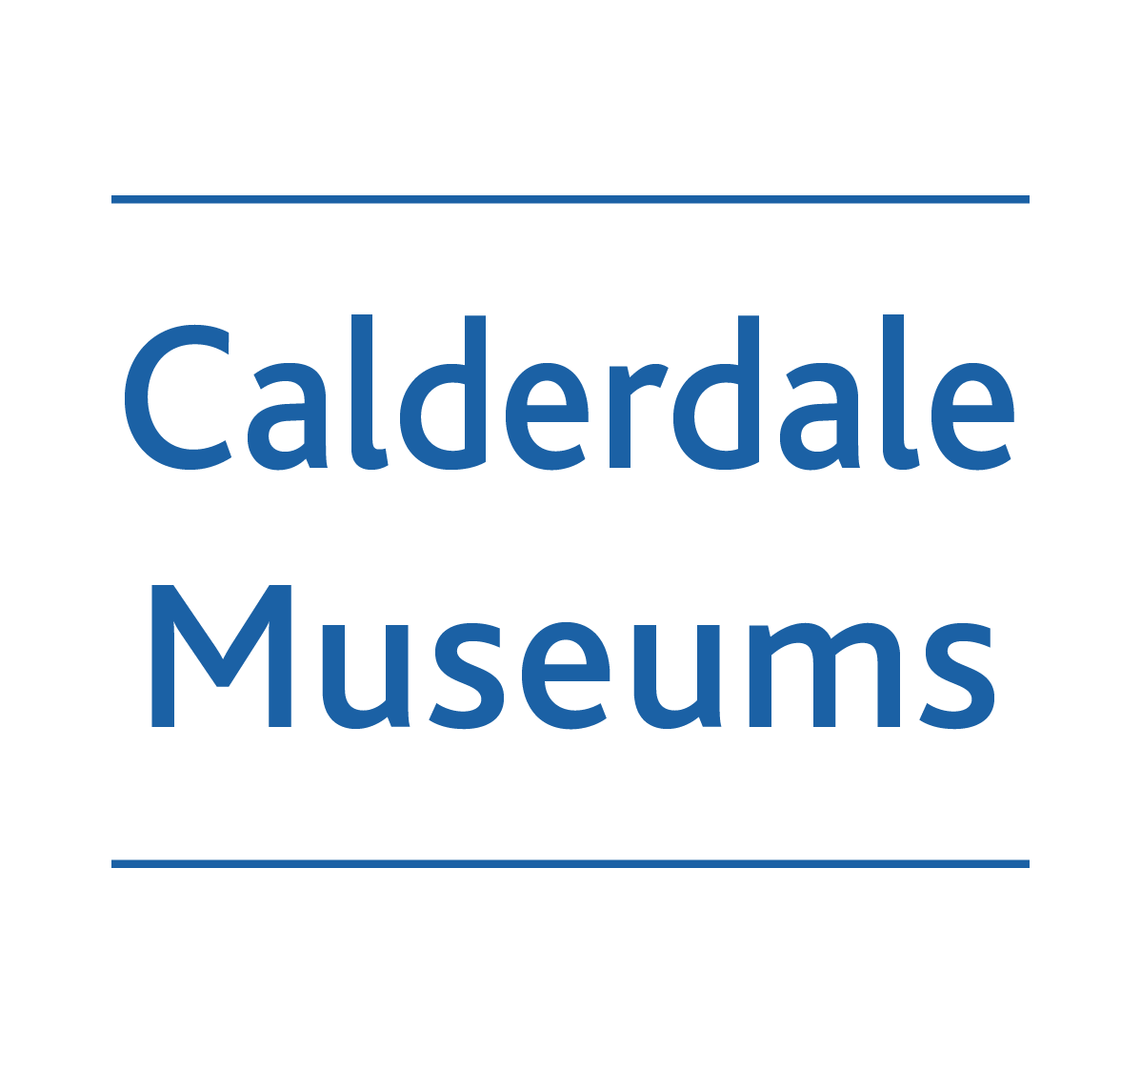
Cragg Vale Coiners- Who’s Who

JOHNATHAN BOULTON
Agreed to give money for the murder of Deighton.

JAMES BROADBENT
Member of the Coiners gang. He gave evidence on Hartley for the promise of reward. He subsequently went back to York to change his statement, to say that Jagger and Hartley were innocent.

THOMAS CLAYTON

Also allegedly involved in the murder of Deighton. He found the two men to carry out the murder.

WILLIAM DEIGHTON
Excise man who was sent to investigate the coiners. He captured some of the coiners including David Hartley. He was later shot by Matthew Normington.

LUKE DEWHURST
Agreed to give money for the murder of Deighton. He was the last Coiner to be arrested.

ISAAC DEWHURST
Arrested on information given to Deighton by Broadbent.

WILLIAM FOLDS

Also implicated in the murder by Broadbent.

DAVID GREENWOOD
Lived at Hill Top Farm, Cragg Vale and became the treasurer for the Coiners.

DAVID HARTLEY OR KING DAVID
Leader of the Coiners gang. He was arrested by Deighton and hung on 28th April 1770.

GRACE HARTLEY
Wife of David Hartley.

ISSAC HARTLEY
Brother of David who promised £100 to anyone who got rid of Deighton. There was insufficient evidence to substantiate this so he got away with it.

JAMES JAGGER

Arrested at the same time as Hartley for coining and taken to York. He was later freed.

JUSTICE LEEDES
Issued Hartley’s warrant.

ABRAHAM LUMB
Agreed to give money for the murder of Deighton.

MATTHEW NORMINGTON
Involved in the shooting of William Deighton. It was Matthew Normington’s shot which killed him. Also released, found not guilty due to the same reasons. After new evidence, he was caught and hung in York on 18th April 1775. He finally confessed that only he and Thomas were involved in the murder.

JAMES OLDFIELD OF MIDGLEY
Executed with Hartley.

ROBERT PARKER
A Halifax solicitor who sought to capture Deighton’s murderers.

JOHN PICKLES
Arrested on information given to Deighton by Broadbent.

THOMAS SPENCER
Allegedly involved in the murder of Deighton. Agreed to raise the money for Deighton’s murder. Later convicted of leading corn riots in Halifax and hung on Beacon Hill in 1783.

JAMES STANSFIELD
Persuaded Broadbent to go to York and retract his statement regarding Hartley and Jagger. This Broadbent did but the two men were not released.

JOHN SUTCLIFFE
Landlord of Broadbent and the first man to be arrested on the information Broadbent gave to Deighton.

ROBERT THOMAS
Involved in the shooting of William Deighton. Released, found not guilty of the murder due to the number of times that the witnesses changed their stories! In 1774 new evidence came to light and Thomas was finally charged with highway robbery on 6th August 1774. Executed in Tyburn, York.

CHARLES WATSON WENTWORTH, THE MARQUIS OF ROCKINGHAM
Took charge of the case after the murder of Deighton.

