
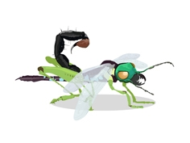
Design a Super Bug!

Design a Super Bug using bits from any minibeasts and label the different parts

It is called a ___________________________________

It is a Super Bug because…

By __________________________________________________

Year ____ School ____________________________________

