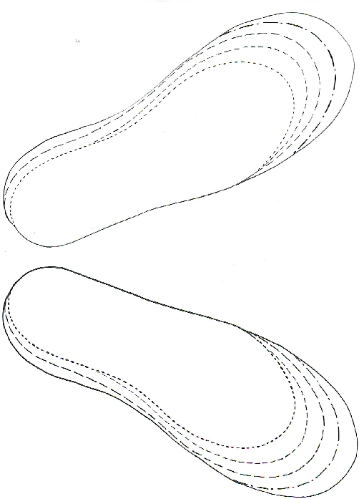In Your Shoes: Pattern Left and right soles 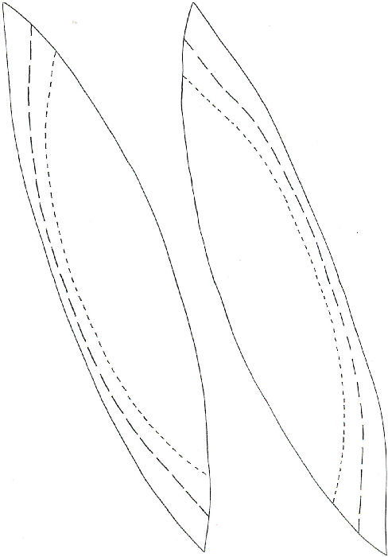
In Your Shoes: Pattern Left and right upper 1
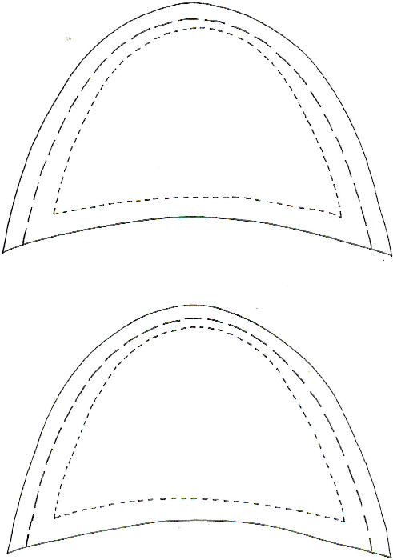

In Your Shoes: Pattern Left and right upper 2

