Picturing Leeds in the time of

George III

This resource was created using archives from the British Library.
NOTE: These activities use images and a PowerPoint attached to this Learning Story on MyLearning. Please visit the Resources page to view and download these resources.

Theme/Enquiry Question and background notes

What do maps usually look like?
These drawings from the George III collection look very different from what you might expect. Why is that and what information can they tell us about life in the eighteenth century?
These drawings are visually beautiful but can be hard to interpret in detail without context. Setting the scene with a background study on George III may help alongside the use of Digimaps for Schools to compare the 18th Century George III maps with 1850, 1950 and the present day.
The drawings are all part of a much larger story – links can be made with other resources on MyLearning.

Aims
- To analyse and interpret18th century maps of Leeds
- To understand the city's growth, development, and the social, economic and cultural factors that influenced its development.
- To build knowledge of how living conditions altered for people in all areas of society in Leeds from the 17th and 18th centuries, contrasting the lives of the rich and poor.
- To grow an understanding of continuity and change throughout history and the effects of key events, such as legislation.
- To develop the skills to engage with a local history study and draw contrasts and connections between different periods.

Curriculum Links

- KS2 History:
  - A local history study
    - a study over time tracing how several aspects of national history are reflected in the locality (Agricultural and Industrial Revolution – Leeds maps)
    - a study of an aspect of history or a site dating from a period beyond 1066 that is significant in the locality (Harewood House, Gawthorpe Hall, Kirkstall Abbey, Bramham Park)
  - Changes in an aspect of social and economic history.
- KS3 History: A local history study
  - a study over time tracing how several aspects of national history are reflected in the locality (Empire, Agricultural and Industrial Revolution).

Activity Ideas

1. Using George III maps to explore Leeds through a global context
Corrina Stewart from Bramhope Primary School developed this lesson plan guidance to help students to explore King George’s collection through historical enquiry.
There are some resources that will be particularly relevant for schools in Harewood and Kirkstall.

Objectives:
- Introducing the George III maps and drawings
  - Students will be introduced to the George III maps and learn about their historical significance. They will learn that he was a passionate collector of maps and had a love of geography and exploration.
  - Students will explore the different types of maps created during George III's reign and their uses.
- The world in the 18th century
  - Students will use a map to learn about the major events and movements of the 18th century that affected the world.
  - Students will analyse how the world map changed during this period.
  - Students will identify the countries and empires that existed during the 18th century.
- The British Empire
  - Students will learn about the British Empire during George III's reign and the role of maps in its expansion.
  - Students will analyse the changes in the British Empire over time and how they are reflected in maps.
  - Students will compare the maps of the British Empire during George III's reign with modern day maps.
- Map making techniques
  - Students will learn about the techniques used to create maps during George III's reign.
  - Students will practice creating their own maps using similar techniques.
- Map analysis
  - Students will analyse a variety of George III's maps and identify the key features and information presented.
  - Students will compare and contrast different maps to understand their purposes and audiences.
- Creative mapping
  - Students will create their own George III inspired map that reflects a particular area or region of Leeds that they are interested in.
  - Students will present their maps and explain the historical context and significance of their design choices.

Lesson 1 – Introduction to George III maps
Images of the maps and of King George III can be found on the associated MyLearning resource.

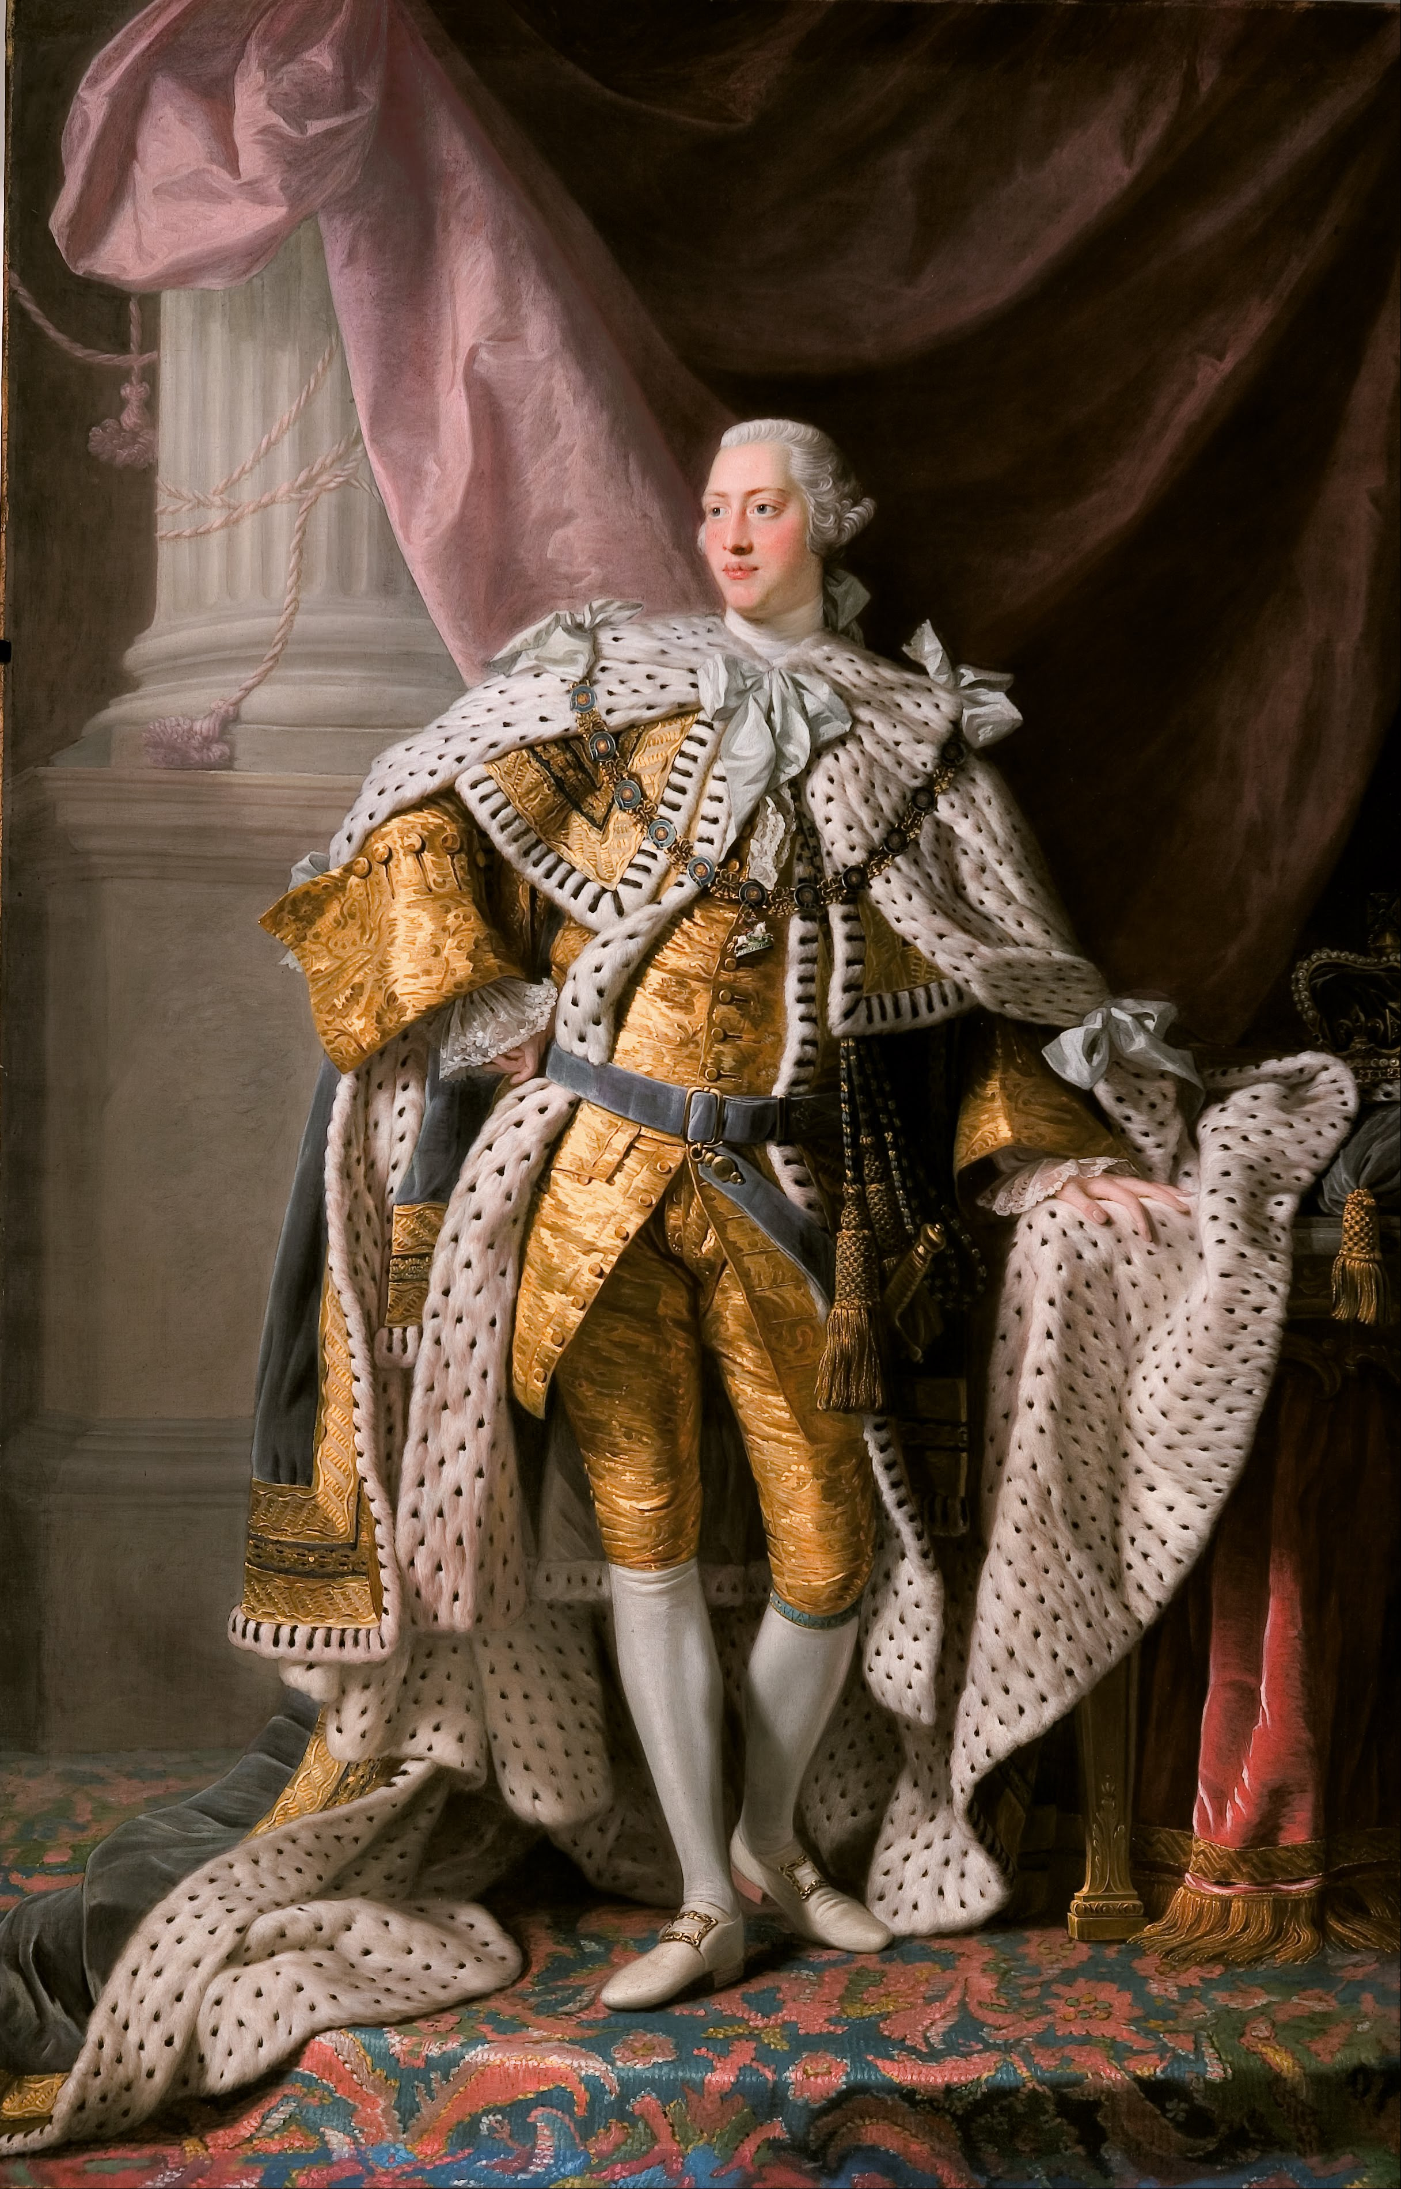
Image of King George III in coronation robes - Google Art Project(cropped)
Wikimedia Creative Commons Licence

- Introduce George III as monarch and provide some context about his reign including the global overview and some of the things happening at the time (The Transatlantic Trade in Enslaved African People, Act of Union, persecution of Catholics, The Age of Enlightenment, Agricultural Revolution, Industrial Revolution, and American Revolution).
- Introduce the topic of 18th century Leeds and explain the importance of studying historical maps in understanding the development of a city.
- Show students examples of 18th century maps of Leeds (including George III maps) and modern-day maps of Leeds side by side.
- Ask students to make observations about the differences between the two maps. Use Digimaps for Schools.
- Distribute copies of the George III maps to each student (maybe include a wider selection of other maps too).
- Students work in pairs or small groups to analyse the maps and answer questions:
  - What landmarks can you see?
  - What does the map tell us about the layout of the city?
  - What does the map tell us about the economy and social structure of the city?
- Students come back together to discuss their findings.

Lesson 2: Compare 18th century Leeds to modern-day Leeds:
- Show students a modern-day map of Leeds.
  - Instruct students to work in pairs or small groups to compare and contrast the 18th century map of Leeds to the modern-day map.
- Ask students to answer the following questions:
  - What has changed in the layout of the city?
  - What landmarks from the 18th century map are still present today?
  - How has the economy and social structure of the city changed over time?
- Come back together as a class to discuss their ideas.

Lesson 3 – Understand the factors that influenced the development of Leeds from the 18th century
- Working in pairs or small groups:
  - Ask students to research and identify the social, economic and cultural factors that influenced the development of Leeds during the 18th century.
  - What industries were prominent in Leeds during the 18th century?
  - How did the growth of industry impact the development of the city?
  - What cultural factors influenced the development of Leeds?
  - How can the George III and other historical maps be used to support your findings?
  - Come back together as a class to discuss their findings.

Lesson 4 - A detailed exploration of the maps of Harewood House and Gawthorpe Hall.
- Using the George III map of Gawthorpe Hall in 1722 discuss the following questions:
  - Why does the map look like that? How does it compare to maps today?
  - What materials and techniques were used to draw it?
  - Do you think it was accurate at the time?
  - What was happening at the time? – locally, nationally, globally.
  - Who lived at Gawthorpe Hall?
  - What happened to Gawthorpe Hall?

Lesson 5 – A detailed exploration of the maps of Harewood House and Gawthorpe Hall. The history of Harewood House.
- Create a class global timeline. What else is happening in the world?
  - Add details to show the links to British monarchy – past and present.
  - Add details to show the links to transatlantic trade in enslaved African people.
- Research the development of the Harewood Estate including the development of the landscape by Capability Brown.
- Distribute copies of the George III drawings of Gawthorpe Hall and Harewood House to the students and ask them to examine them closely.
- Compare the old maps with modern maps and pictures to identify the differences in layout and design of the house and gardens.
- Identify and mark on the map any changes in the layout or design of the house and its surrounding area over time.
- Discuss the changes identified and what they reveal about the history of Harewood House.

Lesson 6 – A detailed exploration of the maps of Harewood House and Gawthorpe Hall. The historical significance of Harewood House and surrounding area.
- Show images of Harewood House from different time periods and ask students to analyse the changes in the design of the house and its surrounding areas.
- Encourage students to consider the historical significance of these changes and what they reveal about the people who lived there and their way of life.
- Write a short paragraph about what they learned and their reflections on the historical significance of Harewood House.
- Emphasise the importance of understanding the history of Harewood House and its surrounding areas in order to gain a deeper appreciation of the site's historical significance.

Other activity ideas
- Design a museum exhibit: You could include the George III topographical drawings, additional images, videos, and text to show what you have learned about Leeds through the ages starting from the 18th century. Use the Leodis website to find more images and information about Leeds from the 19th and 20th centuries.
- Produce a historical podcast: In small groups, create a podcast series on the history of Leeds. Each episode could cover a different period of time using the George III topographical drawings as the hook. Students could be interviewed in character as expert historians, do dramatic readings of primary sources, and recreate audio clips of historical events.
- Conduct a historic walking tour: In small groups, research and create a guided walking tour of Leeds historic sites. You could walk to sites such as City Square (using the George III drawing of the Cloth Hall which used to be situated there) or the old infirmary. Use Google Maps to plot out the tour and create an accompanying brochure that explains the significance and history of each landmark.
- Build a Leeds model: As individuals or in groups, create a physical model of a significant Leeds landmark, such as Kirkstall Abbey or Harewood House. They can use materials like cardboard or clay to bring the model to life.
- Produce a historical news report: Working in small groups or as individuals, create a news report that covers a significant event or time period in Leeds history. Write a script, record your group giving the report, and edit it together using iMovie or other video editing software. You could focus on Harewood House, Kirkstall Abbey or Bramham Park using the George III topographical drawings as a stimulus.
- Create a biographical poster or a leaflet about George III using iPads to research. You could design and illustrate the poster or type up the leaflet using relevant information from your research. Show how creative you can be with different designs and layouts.
- Build a timeline showing the major events and developments during the reign of George III – include global, national, and local events.
- Create a video report or iMovie on the impact of George III's reign on Britain and the world. You will need to research and select key events and figures to focus on within a given time period.
- Develop a role-play performance about life in Leeds based on one of the George III topographical drawings of Leeds. You will need to brainstorm ideas about what you see in the drawing, do some research and use your imagination to develop characters and your role-play performance script. Think about how to find out what people at the time were worried about - What were the issues they were facing? What changes were happening in their lives? How did they feel?
- Create a short animation showing the key aspects of George III's reign, including his influence on the arts, sciences and technology. You could use digital tools to create your animations.

Discussion ideas
- Discuss the question ‘What is a map’? What are the different types of maps that you have seen? You might include discussions about:
  - political maps
  - physical maps
  - topographical maps
  - topological maps
  - climate maps
  - nautical maps
  - thematic maps
  - road maps.
- Take part in a debate about whether George III was a successful monarch or not. You will need to research evidence to make your points, taking into account the perspectives of different people. You will need to write down and present clear arguments for your case.

