Shoe Project: History Activities

Learning Objectives
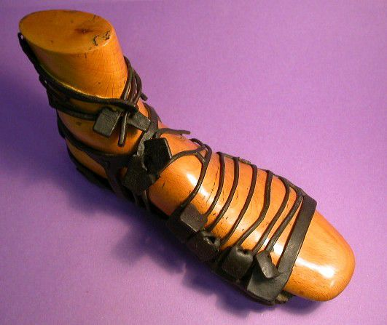
- To develop knowledge and understanding of Roman people living in Britain.
- To develop knowledge and understanding of people from different sections of society living in Victorian Britain.
- To develop knowledge and understanding of the impact of the Second World war on Britain.

Activity: Who wore these shoes?

Introduction
Work with the pupils to try and label all of the shoes and chronologically order the Roman Sandal, Queen Victoria's Wedding Shoe, Whimsical Walker Clown Shoes, Victorian Concealed Boot, WW2 Women's Land Army Shoe and 1950s ladies fish skin sandals on a timeline, highlighting how fashions, shoemaking methods and materials have changed over time.

Pupils can use this Interactive timeline to find out about various other shoes from different periods.

Roman:
- Look at the Roman Sandal, focussing on the hobnailed sole. Compare it to modern shoes with studs or spikes such as Christopher Chattaway's Running Shoes.
- Consider the type of surface Romans walked on. Find out more about the introduction of roads in Britain, your nearest Roman Road and what else Romans wore.

Victorian:

Whimsical Walker Clown Shoes and Queen Victoria's Wedding Shoes
- Look at the Whimsical Walker Clown Shoes and Queen Victoria's Wedding Shoes. Compare and contrast the features and purpose of their shoes.
- To explore their different roles in society, pupils could write a letter from Queen Victoria to the Clown inviting him to perform at Windsor Castle.
- Pupils could chose either Queen Victoria or the Whimsical Walker, discuss what each person would have looked like and draw them, find out more about them and write a biography.
- Pupils could take on the role of either the Whimsical Walker or Queen and show how they would have moved around in their shoes and the gestures they would have used. In a hot seating activity they could ask each other questions, then create scenes in pairs using action and freeze framing.
- Play 'Hunt the slipper', a traditional parlour game. Everyone sits in a circle, one player sits in the middle with eyes shut. Drop a slipper behind someone in the circle, the slipper is passed around the circle behind backs. The person who is 'on' opens their eyes and has to guess who has it. To confuse them the shoe can still be passed around, when caught they swap over.
Victorian Concealed Boot
- Look at the Victorian Concealed Boot. Explore the features of the shoe and how it was found, annotate the boot with the pupils ideas for why people may have hid shoes in their houses.
- Pupils could imagine they were the child who wore this boot and write about the day it was hidden in the thatch of a cottage.
- To explore diffrences in wealth and class they could make comparisons between the boot and Queen Victoria's shoes.
- Research shoe superstitions and sayings and explore their meanings, e.g. Queen Victoria had old shoes thrown after her on her arrival to her new home, attaching old shoes to a wedding car or putting shoes on the table.

Second World War:
- Look at the WW2 Women's Land Army Shoe and related resources. Use them to explore the purpose of the Women's Land Army. Annotate the features on this shoe which make them suitable for the work.
- Pupils could imagine the War has just started and make Women's Land Army recruitment posters.
- They could write a letter from Winifred to a friend, after the war had ended, explaining the work she did, her uniform, etc.
- Look at the 1950s ladies fish skin sandals. Ask pupils to think about why fish skin leather was used to make shoes during and after the war. This could link to work on shortages and rationing.
- Pupils could think about the work of a cobbler then design a poster which encourages people to 'Make Do and Mend' their own shoes.

