Staff Bulletin February 1940 (front page)
Marks and Spencer
HEAD OFFICE: 82 BAKER STREET, LONDON, W.1
Staff Bulletin
FEBRUARY, 1940
Our Contribution
A business like ours is a public service and a public service must meet the calls which these changing times make. We are carrying on our job of raising or at least maintaining the standard of life for our customers by fighting down avoidable increase in the price of goods a great public needs, and making their incomes go as far as possible. It is not easy. Some costs must go up, some supplies must go short, new lines must replace old that perforce diminish on our counters. But the work goes on, the adaptations are made and we can all be of good heart and have a proper pride that in this unromantic but very practical way we are helping in the nation’s cause.
But, as a glance through these pages will show, this enterprise in which we are all sharing is doing what is more obviously war work. We are sending our recruits to the fighting services; already they number hundreds, as time goes on they will number thousands, and they include men in every one of our departments. We are staffing A.R.P. services and providing for the safety of our own staff and customers in the event of an emergency. We are feeding evacuated children. We are training canteen workers. In many other ways we are playing our part, and the tale is not yet even half-told. We can hold our heads high in these testing times, and say in the time-honoured words – “Be strong and of good courage.” Simon Marks
The New Order
At the end of last August we were talking of summer holidays behind us or still to come, leading peaceful, orderly lives – some of us apprehensive about the political situation but most of us tranquil enough. Then suddenly our security was torn up by the roots, war was upon us, the world was in chaos.
In that first fortnight it seemed as if our lives were shaken to their foundations, but gradually in the succeeding five months a new order of things has emerged and our lives proceed once more according to plan.
The newspapers and wireless have kept us well informed as to the new shape of the national plan and we each of us know for ourselves the changes in our own lives. But in between these two and sharing in both is another community to which we all belong – the world of Marks and Spencer. Here is still another pattern reshaped by the war, and one moreover which it is difficult to see in its new perspective. This “Staff Bulletin” is an attempt to show what store life looks like under war-time conditions.
WELFARE OF THE INDIVIDUAL
On other pages you will read of the changes which the new order has brought into our business world. Our personnel policy, however, remains unchanged and the same care is still being shown for the interests of each individual employee. Determined not to increase the widespread unemployment, we have attempted to keep as many people as possible in our service. Reductions, even among temporary staff, have been few.
Welfare activities have not been curtailed in any form. The Welfare Committee is still meeting as usual and none of our benefits has been suspended. Though a number of doctors and dentists have been called up, an efficient medical service is still in operation. In our canteens we have managed to contend with the difficulties of rising prices and rationing without reducing the quality or quantity of food served. Staff Manageresses and Staff Floorwalkers everywhere have shown themselves adequate to meet the new problems of staff welfare which the war has raised.
From the outset there has been a marked absence of panic and a determination to submerge personal anxieties by carrying on with the work of the day. Some of our stores have already experienced air raid alarms and the behaviour of the staff on these occasions has shown that in a real emergency we need not fear for their courage and level-headedness.
In conclusion, we may claim that the searching test of war has not found us wanting and has given us sufficient grounds for confidence in our belief that we have the power to adjust ourselves to any further calls made upon us.
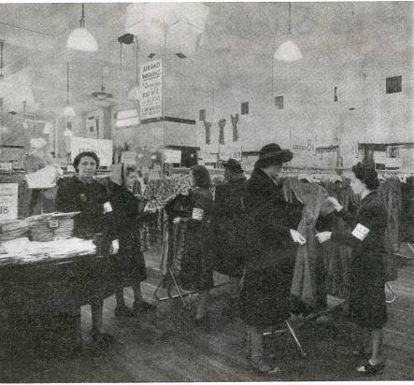
READY FOR A SALE OR AN AIR RAID
( Photograph of women shopping in a Marks & Spencer store, with Sales Assistants wearing ARP Service armbands)

