
One Week’s Ration for an Adult

3 pints of milk

8oz Sugar

2oz Tea

2oz Butter

4oz Margarine

3oz Lard

3oz Cheese

4oz Bacon

Meat. To the value of 1s. 2d. (6p today)

2oz Sweets

2oz Jam

1 Egg

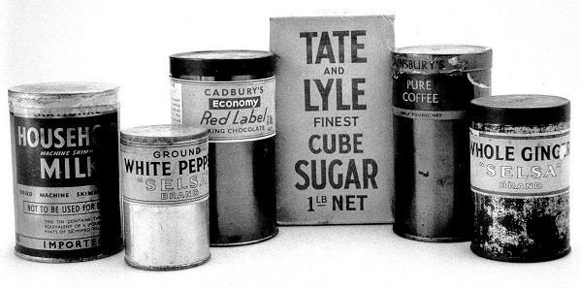

*A child’s ration was exactly ½ the adult’s ration.

Conversion Chart:


1 pound (1lb) = 453g

1 ounce (1 oz) = 28g

1 pint = 568ml

Rationing 1939 – 1954
Family Rations Quiz

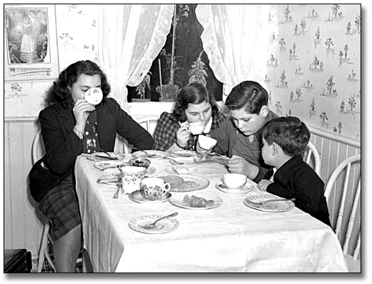
- How much jam will this family get each week?
5 oz 10 oz 12 oz

- How much butter will this family get each week?
20 oz 4 oz 5 oz

- How much lard will this family get for four weeks?
20 oz 30 oz 40 oz

- If an adult gets 2 oz of sweets each week. Which is the correct weight of sweets the children will get each week altogether?
6 oz 3 oz 8 oz

- If an adult gets one egg each week. How many eggs will the family get for 4 weeks?
20 10 15.5

- How much cheese will the family have for two weeks?

30 oz 7 oz 15 oz

- How much milk will the family have for a week?
12.5 pints 7.5 pints 17.5 pints

Rationing 1939 - 1954
Family Rations Quiz


- How much jam will this family get each week?
6 oz 8 oz 12 oz

- How much butter will this family get each week?
14 oz 6 oz 7 oz

- How much lard will this family get for four weeks?
16 oz 56 oz 36 oz

- If an adult gets 2 oz of sweets each week. Which is the correct weight of sweets the children will get each week altogether?
2 oz 4 oz 8 oz

- If an adult gets one egg each week. How many eggs will the family get for 4 weeks?
24 12 10.5

- How much cheese will the family have for two weeks?

9 oz 28 oz 18 oz

- How much milk will the family have for a week?
18 pints 9 pints 12 pints

Rationing: My Family Rations Quiz
(Place a picture/drawing of your family in the box)

- How much jam would your family get each week?

- How much butter would your family get each week?

- How much lard would your family get for four weeks?

- If each adult in your family gets 2 oz of sweets and the children get ½ the adult ration work out the sweet ration for your family for a week?

- If an adult gets one egg each week. How many eggs will your family get for 4 weeks?

- How much cheese will your family have for two weeks?

- How much milk will your family have for a week?

